**UP BikeShare**

Web App

Submitted to:

Prof. Ma. Rowena C. Solamo

Faculty Member

Department of Computer Science

College of Engineering

University of the Philippines, Diliman

Submitted by:

Kevin Oliver Fernandez

Paul Ongoco

John Prudente

In partial fulfillment of Academic Requirements

for the course

CS 191 Software Engineering I

of the

1st Semester, AY 2014-2015

***Unique Reference:***

The documents are stored in the https://github.com/kozloz/nesy

***Document Purpose:***

This document’s purpose is to give the users and members of UP BikeShare some insight on how exactly the system works.

***Target Audience:***

UP BikeShare users and members.

***Revision Control:***

|  |  |  |  |
| --- | --- | --- | --- |
| ***Revision Date*** | ***Person/s Responsible*** | ***Version***  ***Number*** | ***Modification*** |
| MM/DD/YY | Juan de la Cruz | 1.0 | Initial Document; Version number should match the one below. |
| 08/26/15 | Kevin Fernandez  Paul Ongoco  John Prudente | 2.0 | Added everything. |

*Project Title*: UP BikeShare Web App

*Description*: UP BikeShare is a rental system for bikes within the UP Diliman campus. Users enroll in the program through the web application, and are registered into the system for one semester. They are then allowed to use the bikes whenever they log in.

*Context Diagram*:

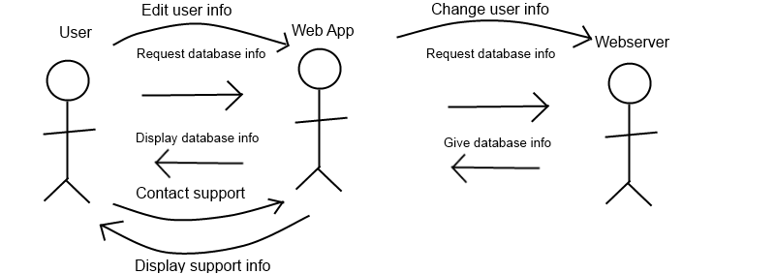

*Entities*:

1. User - member of BikeShare, uses the web application to access information.
2. Web App - displays database information from the web server to the end user.
3. Web server - contains database info and gives it to the web application for display.

Major Inputs:

1. **User Credentials** (Username and password): The WebApp requires users to login with username and password which will be set during user registration.
2. **User information** such as name, birthday, and student number.
3. Users send a **Message** to administrators if there are any concerns or need for support.

Major Outputs:

1. Users can view their **User Profile** which will show the user information that they share with the WebApp.
2. **Account status** which will show the users about their rental status such as when they have delinquencies or accountabilities or if they have or have not paid.
3. User can check his **Rental History** which includes where a user starts and ends using a bike.
4. Users can view **Administrator’s Message** when they request for support and an admin responds.

Major Functionalities:

1. Web app must be able to accept user registration and login.
2. Web app must be able to check user’s status, whether he has paid or not, or if he has any delinquencies and accountabilities.
3. Web app must be able to display user’s rental history.
4. Web app must be able to edit user’s profile when needed.
5. Web app must be able to contact an admin for any issues or concerns.